Computer Graphics(COSC 3p98) Project

Star Wars hyperspace bridge

By Manvendrasinh Rana(6137228)

**Introduction**:

This is a short animation that is around 50 seconds long. The animation consists of 3 different views. It was made using blender software. Although I have used blender before, this was the first time I have done such a big project with it. I would say that blender isn’t the most beginner friendly software. The toolset it provides are a lot and for a beginner, it can be quite overwhelming to navigate through the menus and try to find what you need. What ultimately drove me to use blender was the functionality and toolsets it provides. Furthermore, it is much widely used even in professional environments, and it has a huge community. What persuaded me to go along the animation path, was my huge love for Star Wars. I was pretty set on what I wanted to do for my project. The deadline for the project itself was may 3rd, and everyone who is an avid star wars fans knows what May 4th is. The project overall provided me with a good learning experience and I really enjoyed using blender.

**The Animation**:

The animation begins off with the rebel x-wing starfighter situated at ground level on a rebel base. as the ship raises to a new height, 2 red octahedrons can be seen rotating on both the left and right side along with mapped texture animations on the material. As the ship reaches the height for take off, it waits for the engines to load and lifts off. The ship travels through the rebel space bridge and as it moves along the pathway, the octahedron “crystals” can be seen on the sides with the rainbow color scheme (ROYGBIV). Although it is hard to see as the ship zooms through, they are also rotating and have mapped texture animations as well. The bridge is made dark to really see the contrast and lighting the crystals display around and against the surface of the x-wing and the bridge. As the x-wing reaches the end of the bridge, the ship effectively reaches a speed faster that the speed of light and goes into hyperspace. By travelling via hyperspace, the ship can travel fast and quickly through the galaxy. To emphasize the simulation of a hyperspace, I also added in a white flash that is seen before and at the end of the hyperspace animation section. Once the ship exits the hyperspace, it arrives near the sun. the camera changes orientation and then the ship leaves the scene.

**Models/textures**:

The X-Wing starfighter used assets from <https://sketchfab.com/3d-models/x-wing-starfighter-t-65c-a2-2397144aa2314e8fb03bf131d8f56af4>

Engine used for animation was Eevee.

All other models were made in blender. This would include

**Octahedrons**

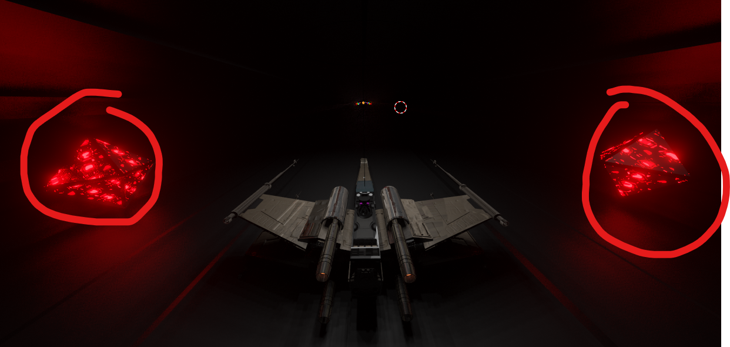

* Top down camera view

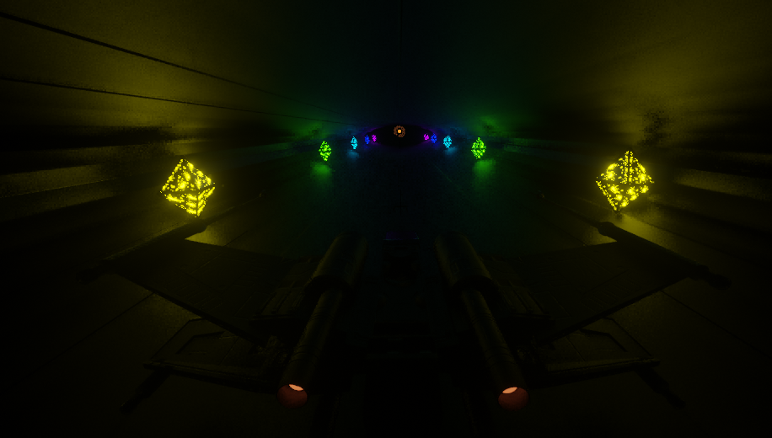

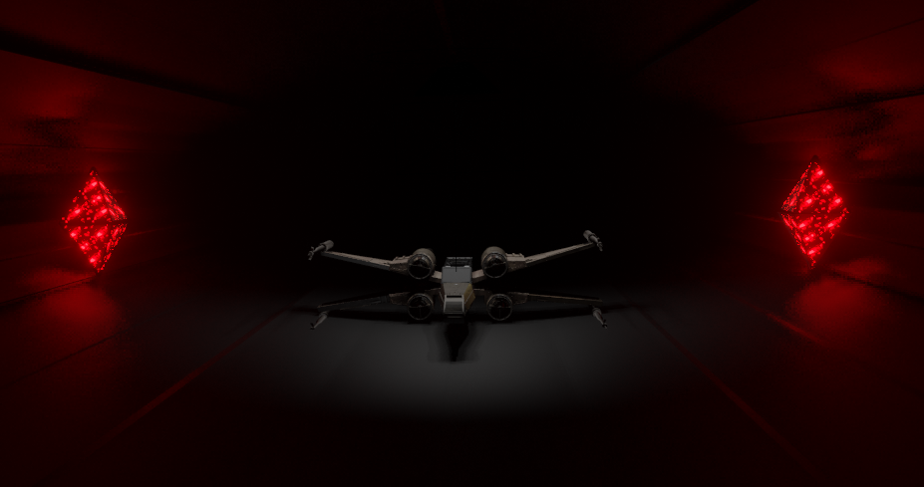

-rendered front view.

The octahedron, is made using 2 cubes. By face selecting one side of the cube, I was able to scale down one side of the cube to 1 point, effectively making a pyramid. Attaching 2 of these together gave me the octahedron. I initially had spheres instead of the octahedrons, but they just didn’t feel as appealing. I opted to use a different shape, and the octahedrons, worked well with respect to the shape of the tunnel bridge. The light glow that reflects off the surface of the bridge really gave a much better effect than spheres. The octahedron also has a wireframe attached to give the thick outline. Without an outline, the texture mapping animations looked as if they were colliding. For the texture materials, I used a mix shader between Principled BSDF, color ramp and emission. The emission would vary depending on what color I wanted the crystal to be. Textures that were mapped with animation include a Voronoi texture and the magic texture. The magic texture looked the most appealing to me as it provided a plasma type /orb type of animation effect. Again, these textures are generic textures that are provided by blender.

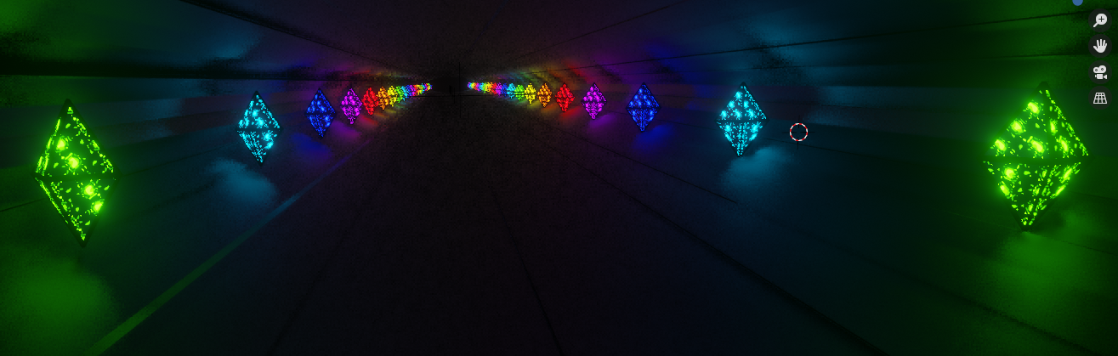

I initially used spheres instead of octahedrons. It didn’t fit too well, and so I changed it to an octahedron. I tried experimenting with different shapes but ultimately the octahedron was what I wanted, because its design with respect to the bridge makes it look like it is embedded into the bridge frame and overall, just provides a better effect. Due to time constraints, I couldn’t implement the sun properly. However, what I initially had in mind was to have a sun with a lava texture that was mapped with animation so when looked upon, you could see the lava flow change while the sun glows hot.

**Sun**: This is the Sun(on the left) in my animation along with the sphere with mapped texture animation.

The sun is using an emission with increased hue saturation values. While the sphere is using a mix shader, principled bsdf and a color ramp. The textures that are used on the sphere include a Voronoi texture and a checker texture. These a mapped with animation. the emission is a bright red orange for the sphere. The environment itself is rectangular prism with black emission. This gives a dark space like environment.

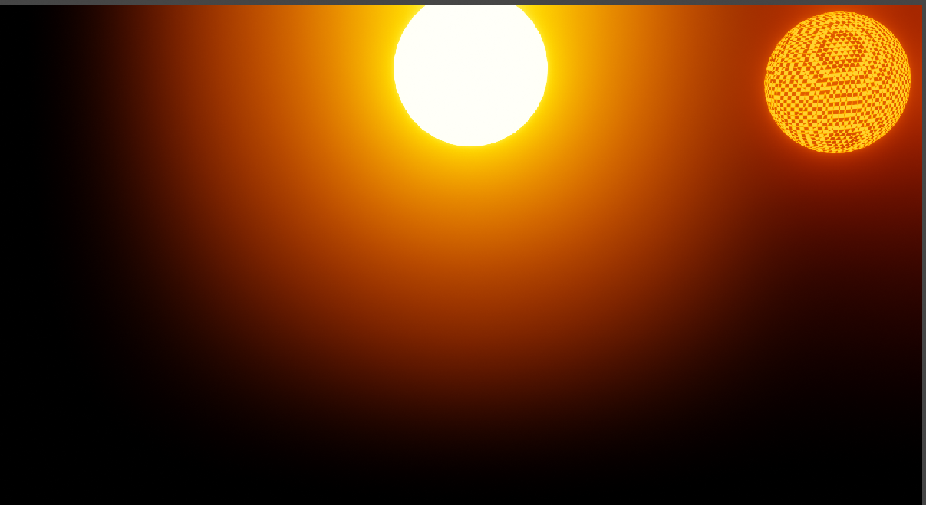

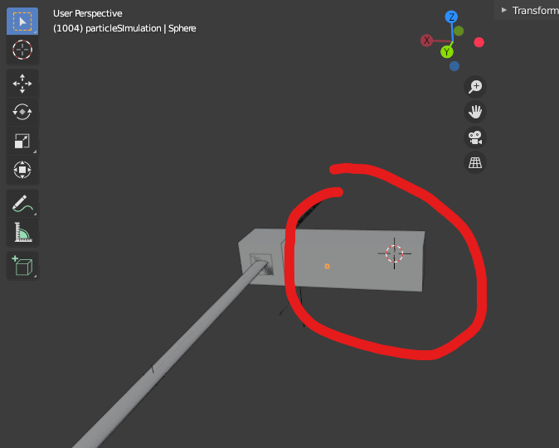

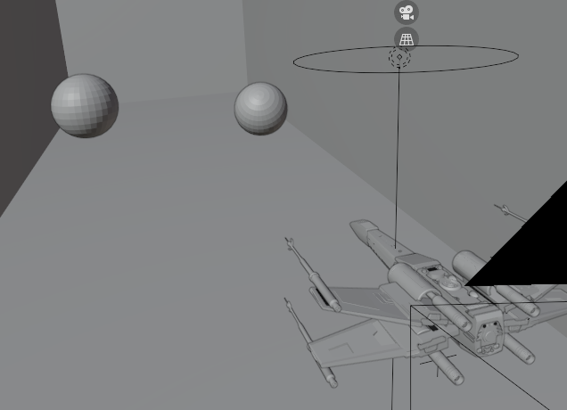

**The bridge**:

The bridge to exit the rebel base is just a cylinder that is scaled on the x axis. I really wanted to go with a sci-fi effect with the bridge and so I tried my best to make it look as alien as possible. The ultra wide length really makes it looks like you are in an alien environment. the material properties used for the bridge, include a principled BSDF with metallic set to max giving the reflective look as light from the octahedron’s glow bounces off the surface of the bridge. The texture I used for the bridge is called stucci with some additional properties like cell noise on the noise basis for the texture. This texture is one of the many textures provided by blender. The pattern used was soft plastic. This gave a very nice-looking blocks/line type of texture that could be seen separated by dark highlights. If you look at the second image, you can see the different line segments as the colours are reflected on the surface. Although hard to see, you can also see the shadows/ light slightly bending as they move along the segments.

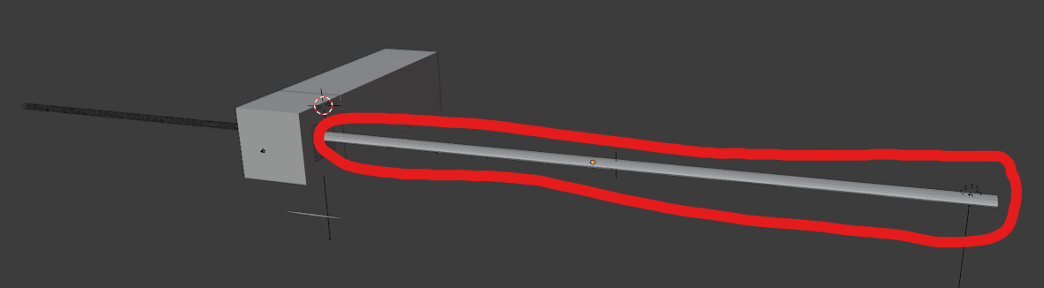



**Flash Cube**:

White cube with emission texture is used for the flash when the x-wing enters and leaves the hyperspace. The cube behind the white cube is the environment with the sun, the ship enters after the hyperspace.

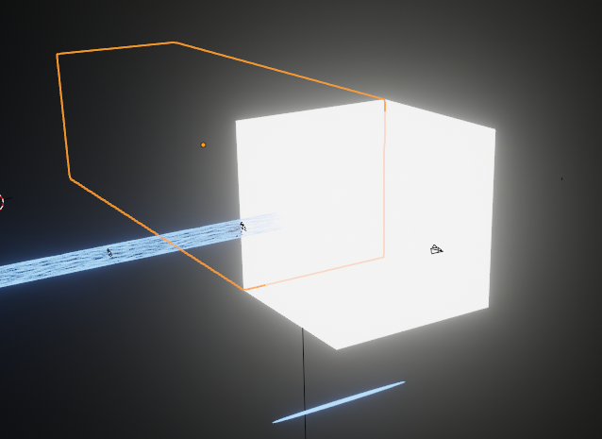

**Particle:**

Particle used in the particle system for cylinder. It is essentially a sphere with an emission texture. Color used is a very light blue to give that effect of travelling in space while particles zoom past you. The object is scaled for the y value and down scaled for x and z value.

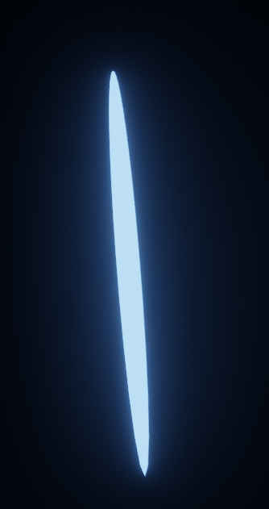

**HyperSpace Cylinder:**

This is the hyperspace system. It is made using a cylinder and uses the particle sphere object mentioned above in its particle system. the particle type is hair. This provides a miniscule multi-particle type effect. The cylinder is essentially divided into small particles. Some changes in the particle settings like hair length, number of particles seed allowed me to tweak the particles system to have a similar effect to what you’d normally see in a star wars movie. I used cycles to make the ship move to the end of one segment and then go back to the initial segment. The only issue I had with this was that as soon as the ship and camera repeated the cycle, you could notice the change slightly. I believe this is due to the disposition, as the cycle repeats, there might be a small variation from when it repeats which causes you to notice the change. This issue was more noticeable when the hole in the middle was bigger. I tried to fix this by minimizing the focal length of the camera so that the black hole in the middle was small as possible.

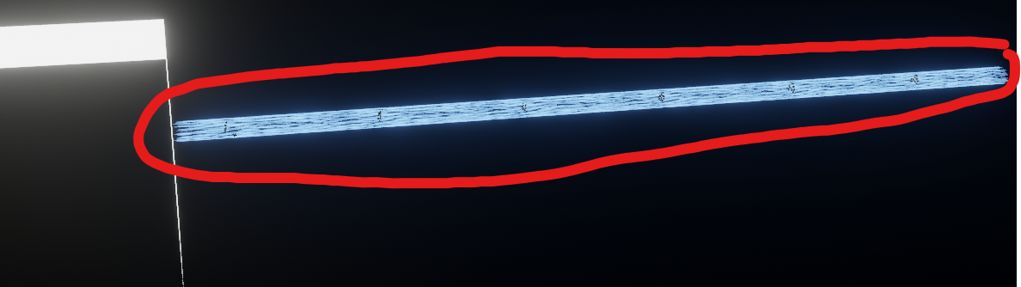

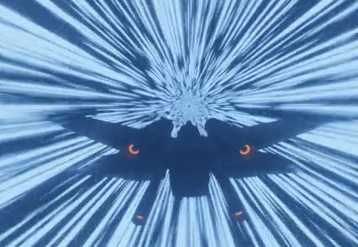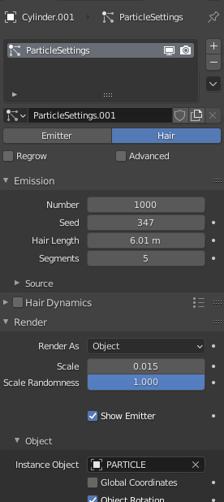

**Plane**

Before the x-wing fighter enters the hyper-space and before the white screen flash, the user will see a black outline at the edge of the bridge. This is to make it seem like as the fighter exits the bridge into space, the fighter instantly goes into hyperspace. It would seem odd, if the fighter could see the white flash rather than just space, prior to exiting the bridge. the plane is simple. It just uses a black emission and nothing else.

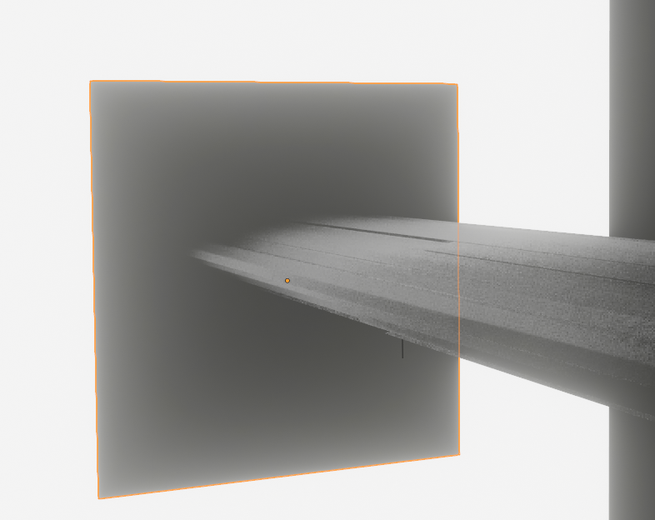

**Lighting:**

I haven’t used too much separate lighting probes inside this animation. most of the lighting comes from the objects with emissions.

The initial start point of the animation actually has an area light. It is too dark inside the bridge to see or make out the x-wing properly. To mitigate this, I used an area light. I thought an area light would make the most sense. If you’ve ever been to an airplane hanger, you will notice similar spotlights. They give an area type of effect which really gives an emphasis to the airplane that is showcased. Below is just an example to show what I mean.

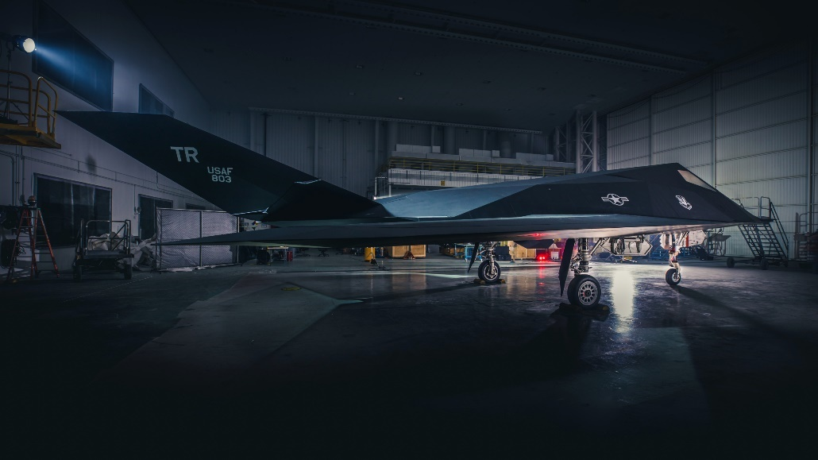<https://ktla.com/wp-content/uploads/sites/4/2019/11/p19-280-10.jpg?w=2560&h=1440&crop=1>

I had one more area light that was in the sun environment. it was directly on top of the x-wing. Initially I had no light here, and I really wanted to make the sun’s light reflecting off the surface of the x-wing without increasing the sun’s emission strength too much. I did this by adding a light on top of the x-wing. I couldn’t add too much variation to the color else, the x-wing would just change color. So I kept the color white but made the light power really high. And this worked really well because you could see the reflection off the metallic surface of the x-wing as if it was actual sunlight.

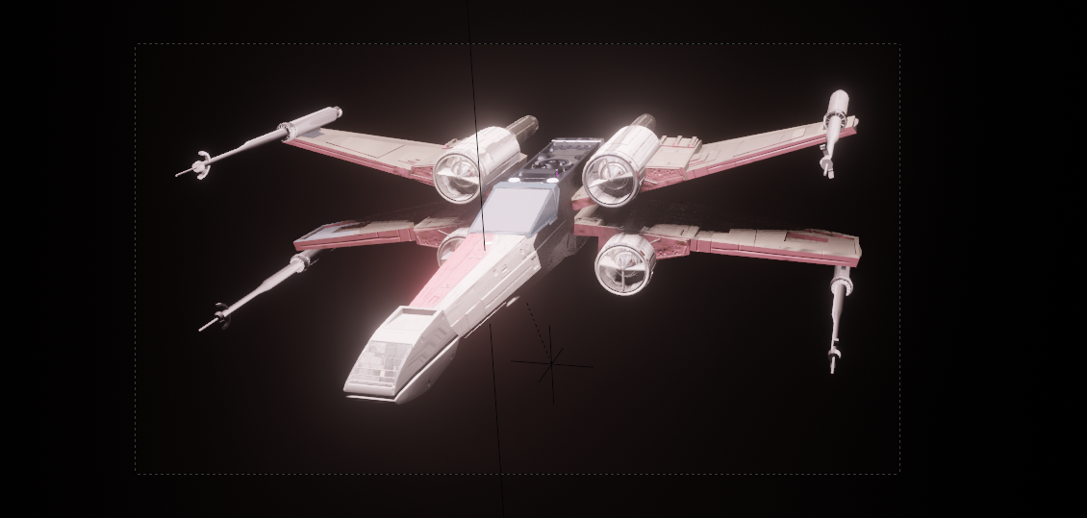

**Sound:**

For the sounds, I tried my best keep the audio files consistent with the animation.

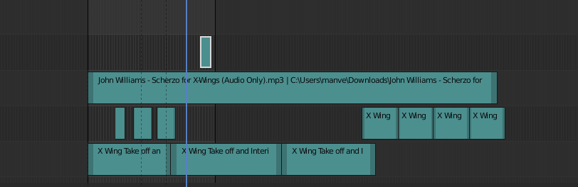

The main audio file I used for the music was John Williams _ Scherzo for X-Wings

<https://www.youtube.com/watch?v=xJzuanMUuS4>

I also implemented x-wing sounds from soundboard

<https://www.soundboard.com/sb/starwarsfx>

**Issues:**

One Major Issue I had was the hyperspace. When travelling through the hyperspace, because I have implemented cycles here, there is a repeating animation. as soon as the animation repeats a small flash can be seen surround the ship. I went through the rendered video and found out that this was occurring at one instance on the repeating animation.

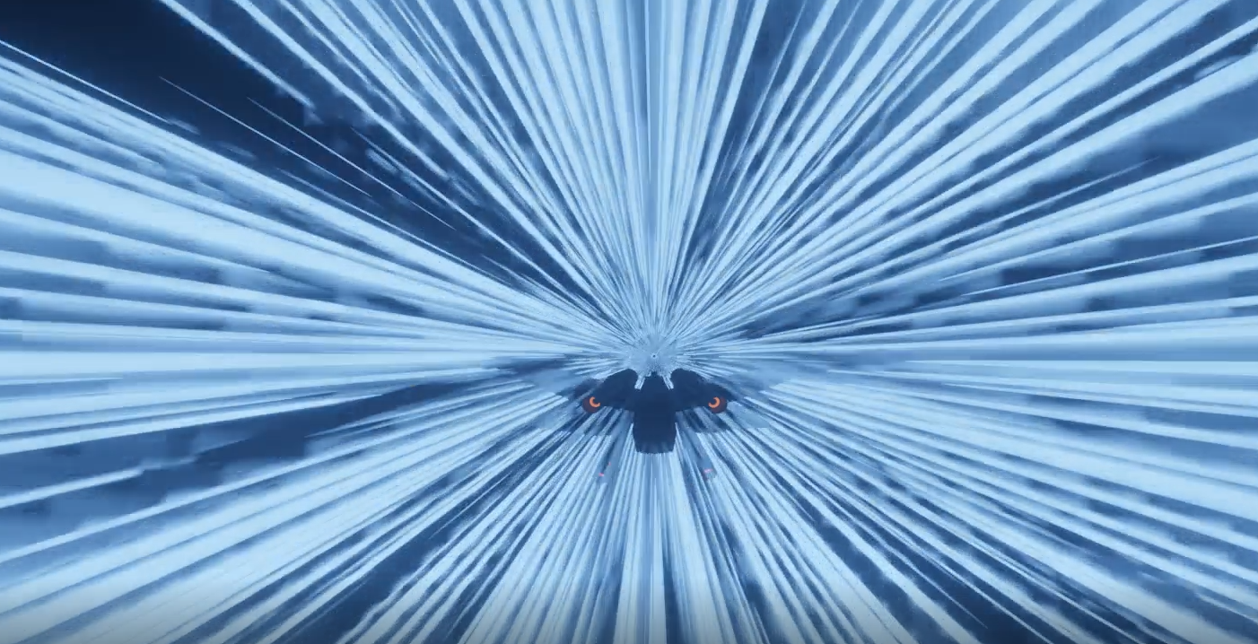

You can clearly see part of the ship disappearing. However, when I check the animation on blender, this is not the case as there is seamless animation. Even though there is seamless animation, I still do notice a small flash on the small back of the ship .I believe the problem lies with blender not rendering the object fast enough on the video as it is 30 frames per second. Missing a frame maybe which makes it seem like a flash when in reality the object should be instantly rendered on the start of the repeating animation.

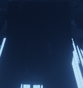

(flashing frame) (normal)

As you can see on the pictures at above feature the back of the x-wing, the left picture is the one for the frame that flashes during the start point of the animation. the right is normal frame throughout the cycle animation.

This was the only major issue I had with my animation. obviously, there were other things I could improve upon, but this one was the only animation breaking one I truly felt.

**Sources**:

X-wing 3d-model: <https://sketchfab.com/3d-models/x-wing-starfighter-t-65c-a2-2397144aa2314e8fb03bf131d8f56af4>

X-wing Soundboard:

<https://www.soundboard.com/sb/starwarsfx>

music:

<https://www.soundboard.com/sb/starwarsfx>